**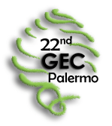***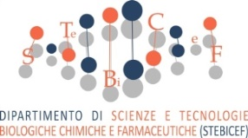*

**PRE-REGISTRATION FORM**

**22nd Meeting of the Group of European Charophytologists (GEC)**

**Palermo, Italy, 17-20 September 2018**

|  |  |  |
| --- | --- | --- |
| NAME: | SURNAME: | |
| IRGC member: | | |
| Non IRGC member: | | |
| Student: | | |
| INSTITUTION: | | |
| ADDRESS: | | POSTAL CODE: |
| CITY: | COUNTRY: | |
| PHONE: | E-MAIL: | |

**Will you give a presentation?**

Oral presentation: Yes______ No_______

Poster presentation: Yes______ No_______

Preliminary title:

Authors:

**Will you participate in the field trip 1 (Lago Preola & Gorghi Tondi)?** Yes**___** No____

**Will you participate in the field trip 2 (Nebrodi Mts)?** Yes___ No____

Please return this form before **10 April 2018** to Angelo Troia

by e-mail: [angelo.troia@unipa.it](mailto:angelo.troia@unipa.it)

UNIVERSITY OF PALERMO, Department STEBICEF (Biological, Chemical and Pharmaceutical Sciences and Technologies), section of Botany and Plant Ecology, via Archirafi 38, 90123 Palermo, Italy.