Guidelines for the validation of research products in the Unipa Iris IR module
Short guide for the validation workflow of scientific research products in the Institutional Repository of the University of Palermo
Drawn up by the Support for research and dissemination of scientific knowledge Section
serviziricerca@unipa.it

Palermo 2022, July

Contents
1. The validation workflow 3
2. Products desktop in departmental view 3
3. Validation workflow, step 1 (WF1) 5
4. Validation workflow, step 1 (WF1): method 7
4.1 First Step WF1: click on the “Modifica metadati” (Edit metadata) button 7
4.1.1 Notes on embargoes 11
4.1.2 Change of product type 12
4.2 Second Step WF1: click on the “Disseminazione files” (Files dissemination) button 13
4.3 Third Step WF1: click on the “Approva” (Approve) button 13
5. Validation workflow, step 2 (WF2) 15
6. Other buttons 17
WORKFLOW GRAPHICS 18
ANNEX 1 – FORM FOR GRANTING PROXY FOR RESEARCH PRODUCT VALIDATION WF2 21
ANNEX 2 Instructions for the embargo of research products 22

2022, July
Update following the upgrade to the DSPACE6 platform.

1. The validation workflow
The validation process on the Iris platform consists of verifying the data entered by authors before they are shown publicly on the Iris Unipa Institutional Repository (www.iris.unipa.it). This is a process aimed at ensuring the quality of the data shown, both to maximise its dissemination and impact and to optimise its use for internal assessment campaigns and ones outside the University.
The validation workflow takes place through departmental grouping and comprises two stages:
- The first (WF1), which consists of a technical control managed by the librarian identified from the members of the working group (set up under Article 6 of the University Regulation for the Deposit of Publications in the Institutional Repository and for Open Access to Scientific Literature, includes: a check on the type identified by the author, the correctness and completeness of the metadata entered (year, authors, volume, issue, identifier codes, etc.) and the choice of option for dissemination of the file or files uploaded.
- The second (WF2) is a final validation, managed by the Directors of Department and/or their representatives, which will determine the publication of the product card on the Iris public portal (www.iris.unipa.it) and the sending of the metadata and the pdf to the authors’ LoginMiur personal pages.
It is possible to “reject” the product in both stages, justifying the choice.

2. Products desktop in departmental view
In the departmental view, there are several product collection boxes with authors belonging to the department. In details, they are as follows:
- The “Incarichi disponibili” (Available tasks) box gathers together all the products in the departmental collection (both those halted at WF1 and those halted at WF2) which are in the “in validazione” (to be validated) status.
- the “tutte le bozze” box (all drafts), in which all products in a draft status with authors affiliated to the department are visible;
- - the “tutti gli incarichi” box (all tasks), in which all products under validation present in both "available assignments" and "assignments taken care of" by individual departmental validators are summed up globally;
- the “incarichi disponibili” box (available tasks), in which are shown all the products of the departmental collection (both those at WF1 step and those at WF2 step) which are in the "in validation" status;
- the “incarichi presi in carico” box (tasks taken over), in which each individual authorised user (Director and/or librarian) views the products he/she has taken in charge, without completing the validation process;
- The “riconoscimenti da validare” box (acknowledgements to be validated) gathers all the products in the departmental collection for which the authors affiliated to the department request the recognition, to be managed by the Department Director. A failure to recognise the author usually generates duplicates;
- the “bitstream da validare” box (bitstream to be validated) collects products with attached files to be validated from which, in a very quick way, actions can be taken.
Once the self-archiving process has been completed by the University's authors, those involved and assigned to perform the validation workflow are alerted by an automatically generated email.
At the same time, in the Department's product desktop, the product summary data will be visible in the 'available tasks' box.

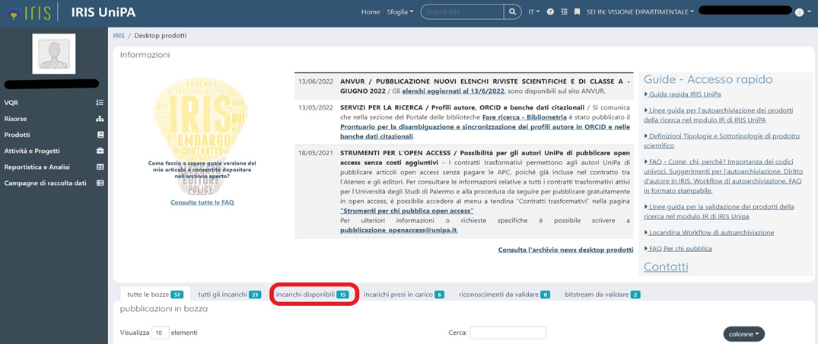

N.B.: In the event that one of the individuals (librarian and Director) involved in the validation does not complete his or her task, the product will be placed in this box (personal and separate for the individual librarian and the Director) and will no longer be visible to any other validators in the department (librarians and the Director's delegates). Therefore, it is highly recommended to either terminate the validation activity once the product has been taken over or, alternatively, to put the activity back into the pool (see Section 6 Other Keys).

The 'Status' column shows which step the product is in:
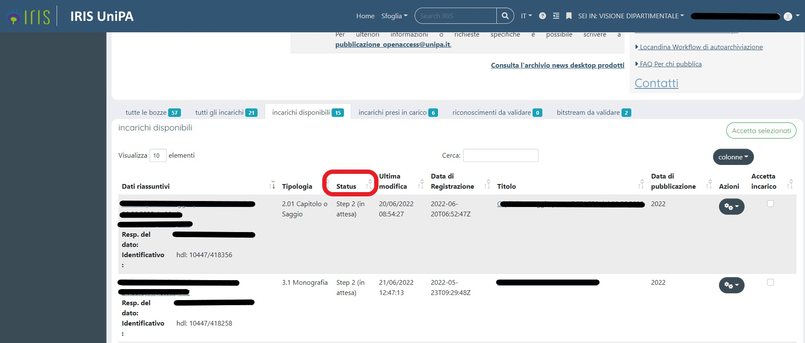

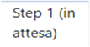 the product must be submitted for technical inspection (WF1) by the librarian.
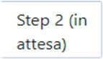 the product must be submitted for final validation (WF2) by the Department Director and/or his Delegate.
Click on the cogwheel in the 'Actions' column to 'Take task'.

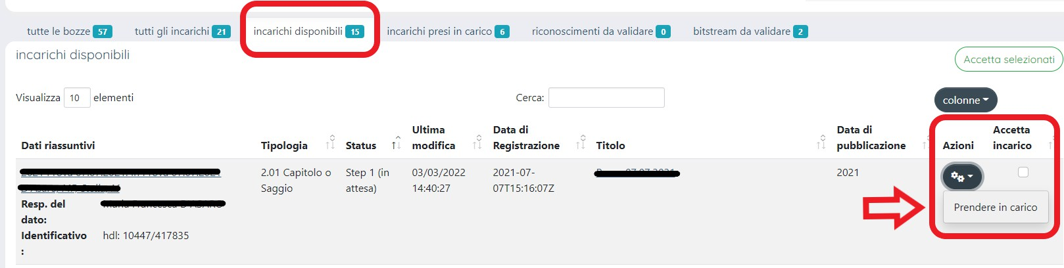

3. Validation workflow, step 1 (WF1)
This part of the workflow comprises a technical assessment of the scientific products and is carried out by the librarian(s) assigned to the individual department. It is a very important moment where:
- verification is made that the product actually belongs to the type chosen;
- one goes ahead with verifying/amending/supplementing the product’s descriptive metadata;
- the correct access mode for the annex is selected and is in line with both the editorial policies and the choice of the individual author regarding adherence to the University Regulation for the Deposit of Publications in the Institutional Repository and for Open Access to Scientific Literature
Once the controls regarding the metadata have been carried out, the pdf is then validated and the workflow product is sent to validation step 2, typically carried out by the Director of the Department and/or his/her representative.
NB: there is no obstacle to both steps being managed by the reference librarian, subject to delegation by the Department Director, a template of which is available – ANNEX 1.
The librarian takes on the products in the department desktop that are marked by the workflow status .
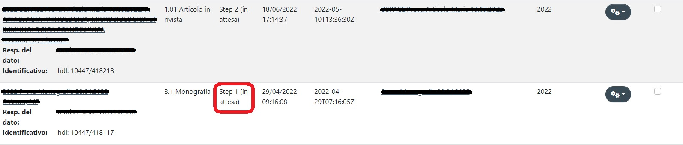

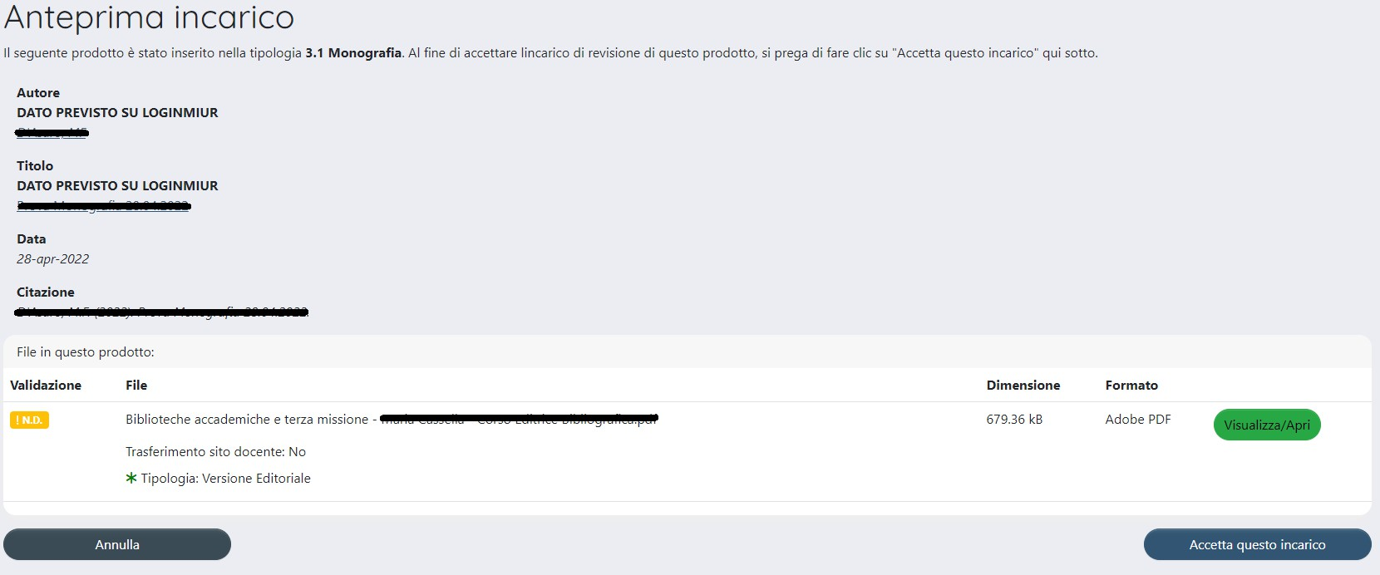
If you click on the wheel in the “Azioni” (Actions) column, you can go ahead and take the task.
At this point, you have a view of:
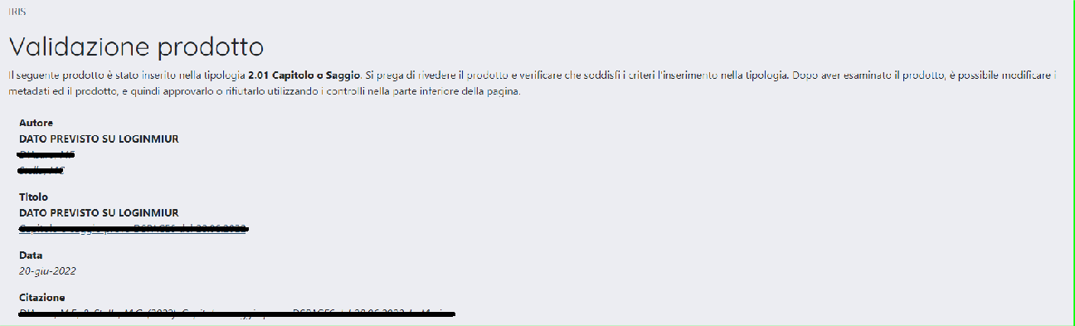
1) the set of all the metadata in the product card (by way of example, see the figure shown below):

- the summary table for the self-archived file(s) with their characteristics
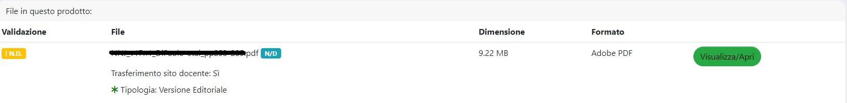
- a set of buttons from where you can carry out some operations on the product card (See section 6 Other buttons).
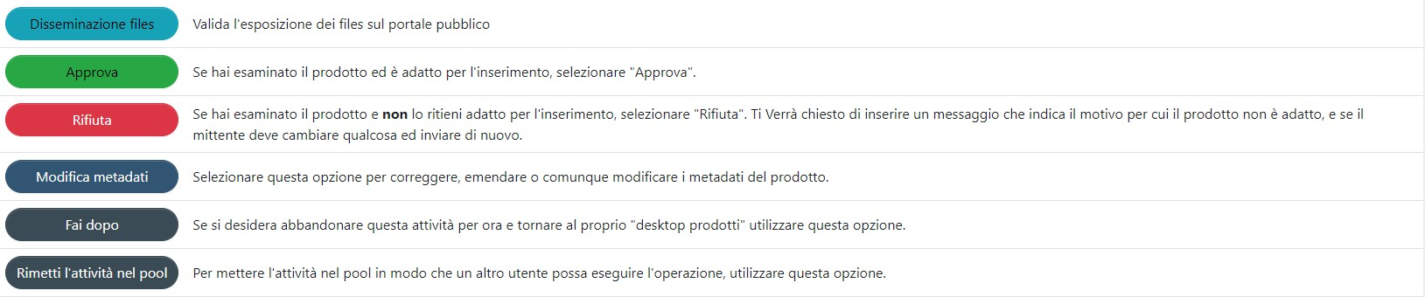

4. Validation workflow, step 1 (WF1): method
This activity is carried out by the reference librarian who, after inspecting the metadata in the summary and examining the pdf, must ALWAYS carry out the following steps:

4.1 First Step WF1: click on the “Modifica metadati” (Edit metadata) button
When you enter the product card and scroll through the descriptive screens, you can:
- make any corrections and/or additions (e.g. correction of the product type – for which See section 4.1.2 Change product type – by entering DOI, volume, issue, etc.). A more detailed analysis of all metadata allows for more timely correction and/or integration;
- have important informations on the choice made by the author regarding adherence to the University Policy for open access and the editorial clauses signed:
The author must make his/her choice regarding Adherence to the University Policy on open access during the self-archiving workflow.
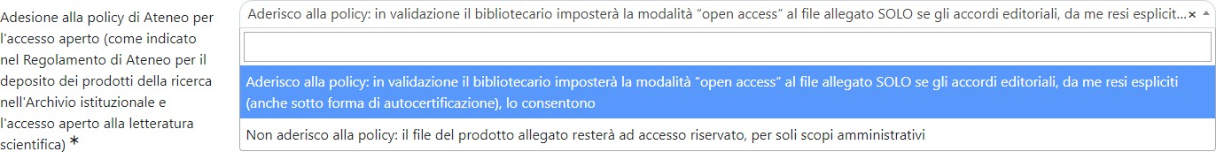
The author must therefore select one of the items in the agreement with the publisher field and/or fill in the related self-certification.
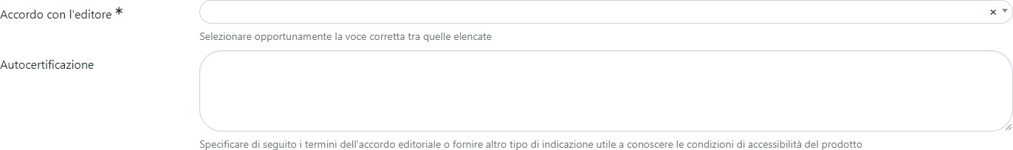
It appears appropriate to recall some passages in the University Regulation for the Deposit of Publications in the Institutional Repository and for Open Access to Scientific Literature, and in particular Article 7, sub-paragraph 4, “During the online self-archiving process, the researcher is explicitly required to decide whether he/she wants to join the University’s OA policy. In case of a refusal to agree on the OA policy, the author will nevertheless be subject to deposit the metadata and files of his/her publications in the repository. The files uploaded on to the repository will not be accessible to the public, except for the provisions of subparagraph 5 here below.” And sections 4 and 5 of Article 8, which specify: “4. If the author, in the act of self-archiving his/her scientific works, refuses to join the OA policy, access to the files uploaded on to the repository will be restricted, so that only the descriptive metadata will be shown to the public. In such a case, the full-text version of the contribution, nevertheless, shall always be available to the author/s. The files may also be handled by a few authorized people (system administrator, members of the Working group), exclusively for those administration and conservation purposes, including internal and national research assessment procedures, for which author/s explicitly allow their use. 5. If the author joins the OA policy, members in the Working group will operate the validation process, that is:
a) where the research paper has originally been published in OA mode, the publisher’s digital version will always be accessible;
b) when the publisher is listed in Sherpa-ROMEO or similar directories, members in the Working group will comply with the individual publisher’s policy on copyright and OA self-archiving as indicated for each journal (publisher’s final version, post-print, pre-print);
c) if the publisher is not listed in Sherpa-ROMEO or similar directories, the research offices and the librarians will comply with the terms of existing contracts with the publisher, that the author must disclose to University when self-archiving the contribution.”
- Select the access policy for the file – Upload
The file access policy will be by default at this stage "Administrators only". It will be the task of the librarian, on the basis of the editorial agreements signed by the author, of consultation of the reference databases (Sherpa Romeo, mailto:OA@unito.it) and on the basis of the author's choice of whether or not to adhere to the Regulations, to proceed, by clicking on the "Edit" button, to select the policy for access to the file (OA, Administrators Only, Embargo).
NB: if the author has clicked on “NON aderisco alla policy” (I DECLINE the policy) the possibility of making modifications on the access policy will be inhibited. It should also be specified that if the author declines the policy, he/she will not be obliged to provide information on the terms of his/her agreement with the publisher and will be able to select the item “Non ho aderito alla policy open access dell’Ateneo” (I have declined the University’s open access policy) in the field called “Accordo con l’editore” (Agreement with publisher) on the menu.
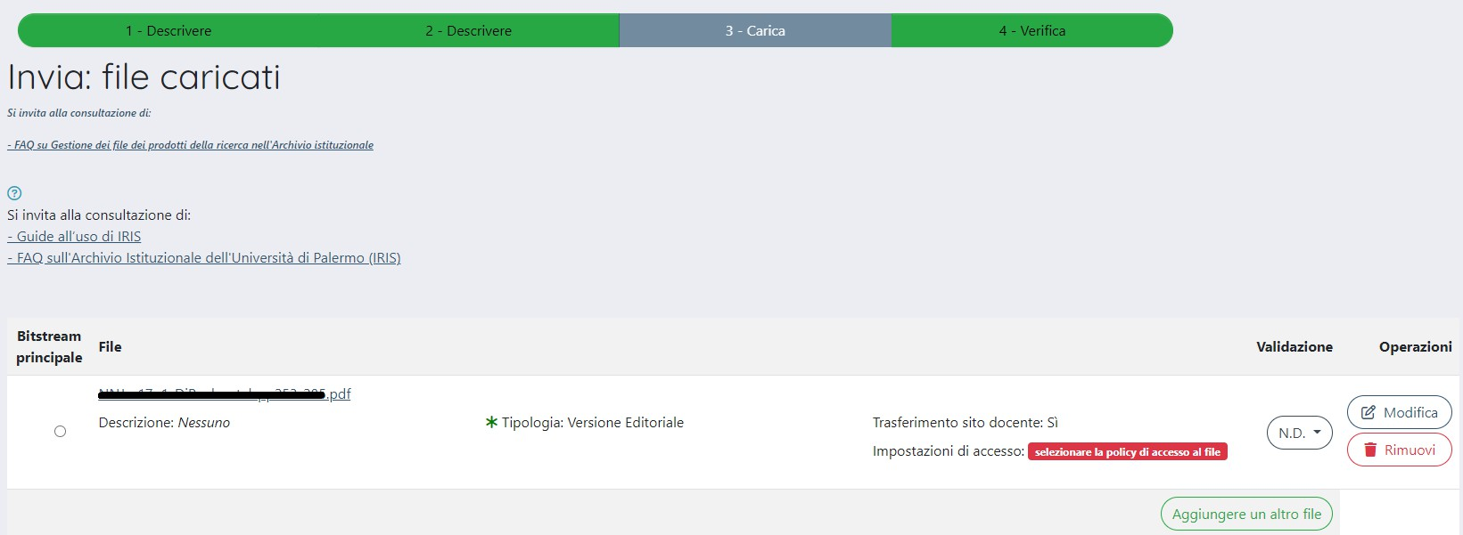
Clicking on the "Modifica” (Edit) button displays a summary page from which you can set the access policy for the file, and view the other metadata values set by the person responsible for the file
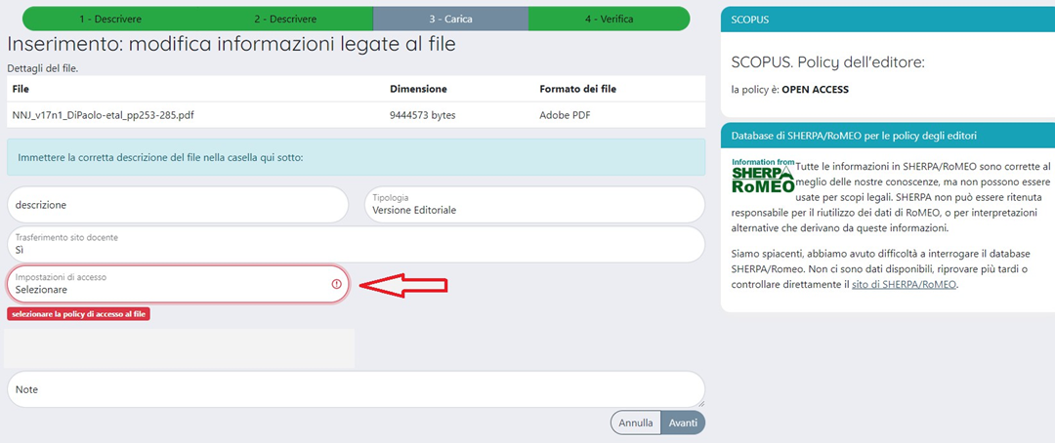

Particular attention must be paid in this stage to:
- checking the consistency of the selected file “Tipologia” (Type) with the uploaded pdf (remember that the possible entries are: Pre-print, Post-print, Versione editorial (Publisher’s version), Altro material (Other material), Tesi di dottorato (Doctoral thesis), Contratto con l’editore (Agreement with the publisher))

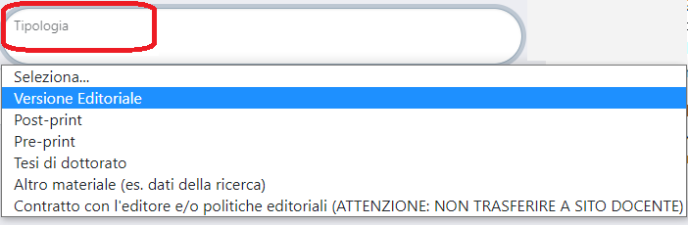
- any content in the “note” (notes) field (e.g. request for embargo or exception See section 4.1.1 Notes on embargoes).
- the choice made for sending the file to the Lecturer Site (LoginMiur).

NB: If the author has entered the entered the file for the contract with the publisher in pdf format, the selection for sending to the Lecturer Site (Login MIUR) must be Invio Sito Docente = NO.
You then proceed with verifying the data entered and conclude.

4.1.1 Notes on embargoes
As provided for by Article 11 of the Regulations, the author has the possibility of requesting an embargo during the self-archiving workflow, if this cannot be detected from the publication itself, by filling in a box dedicated to this, which is positioned in the “Carica” (Upload) step (i.e. the one reserved for uploading the pdf). As an aid to the compilation, operating instructions (see ANNEX 2) have been prepared.
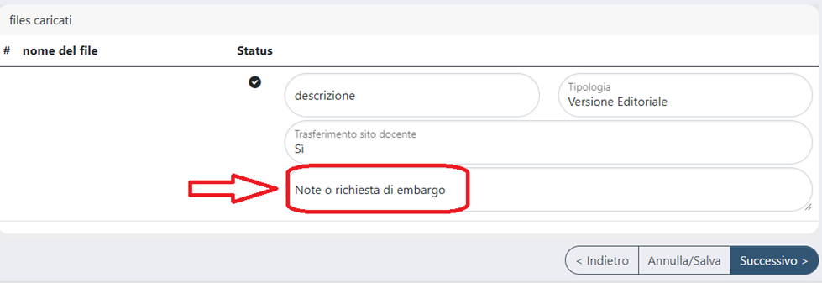
The validator reads any request of the author in the summary area containing the information in the notes field in the “file” column, as shown in the figure below.
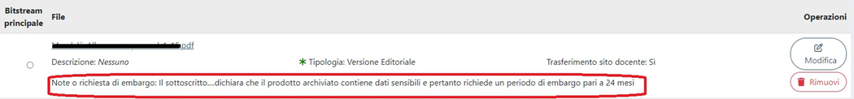
If the librarian must manage the policy with an embargo, with a click on the “Modifica” (Edit) button (See section 4.1 First step: click on the Edit metadata button) he/she selects the related item in the drop-down menu. This will make a calendar appear in which he/she must select the date for the end of the embargo.

4.1.2 Change of product type
The product type is always visible in the descriptive screens, at the top of the page, as shown in the figure.
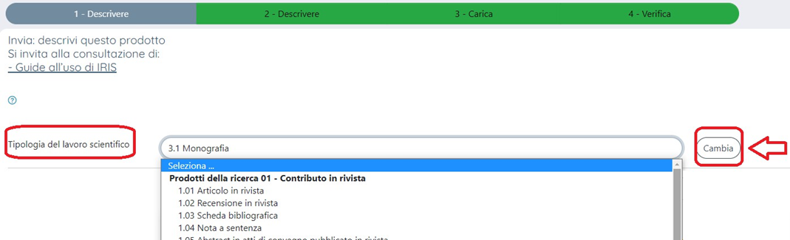
If, from the controls made, the librarian finds an error in the choice of product type selected, he/she can:
- proceed with making the change of type, if he/she has any information to add or there are no additions needed (in this case he/she must inform the data controller via OTRS)
- or, where the author must intervene, the librarian will proceed with refusing the entry and communicate the reasons for this via the appropriate box.
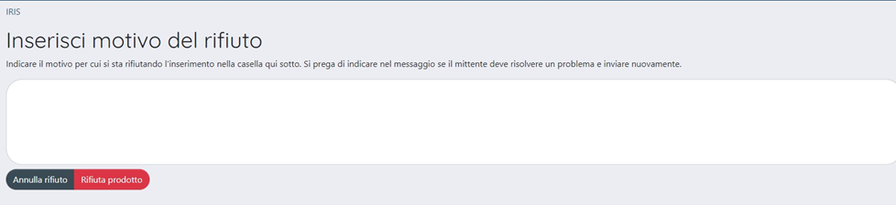

4.2 Second Step WF1: click on the “Disseminazione files” (Files dissemination) button
If you click on the “Disseminazione files” (Files dissemination) button, you can go ahead and validate the full-text. This indicates that the access policy for the file (Open Access, Solo gestori archivio (Administrators), Embargo) has been checked and correctly selected.

Continue by appropriately selecting one of the items from the drop-down menu.
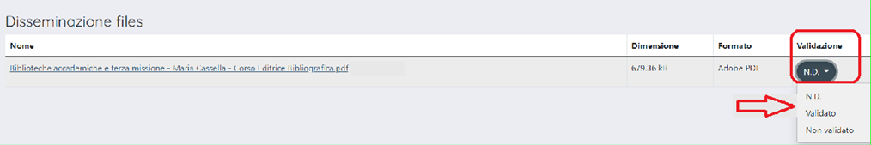

N.B.: If the author has entered the agreement with the publisher in pdf format, the selection in the "Info validazione” (Validation info) column must be set to "Not validated". This will inhibit the display of the file on the public portal.

Clicking on the "torna al workflow” (back to workflow) button takes you back to the view of the file, including the summary string.

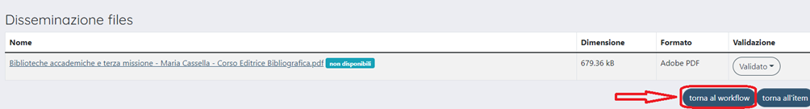

Only in cases of extreme necessity, where the validation of the file is complex and requires further investigation, it is possible to move the selection to "Non validato” (Not validated) and continue with the validation of the metadata, effectively sending the product validation workflow to step 2. The Department Director may still proceed with the approval of the product metadata, which will be displayed on the public portal. A different fate will have the pdf, which will remain obscured on the public portal until its validation by the librarian. The product will only be resubmitted for validation in the event that the librarian needs to intervene on the dissemination options of the pdf (other than the default selection “Solo gestori archivio” – Administrators only).

N.B.: It is essential in this case that the librarian remembers the need to return to the product to perform file validation and dissemination.

4.3 Third Step WF1: click on the “Approva” (Approve) button
After the technical check on the metadata and validation of the pdf has been carried out, the librarian can proceed to approve the product. Clicking on the "Approva” (Approve) button will present a dialogue box, in which a message can be entered for authors and the person responsible for the file.
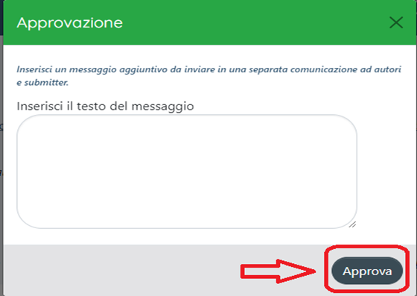
The product is thus transferred to WF2 and processed for final entry in the archive and sending to Login Miur (Lecturer Site).

5. Validation workflow, step 2 (WF2)
Once WF1 is completed, the product returns to the departmental products desktop and is identified by the workflow status “Step 2 (in attesa)” (to be validated (STEP 2)).

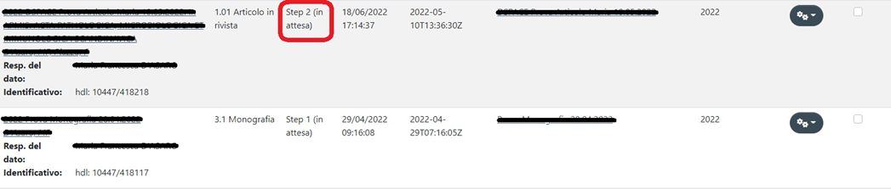

This phase of the workflow is the responsibility of the Department Director or his Delegate who has the task of proceeding to the final validation of the product, which is then displayed on the public portal of the Institutional Archive of the University of Palermo and sent to the personal LoginMiur pages of the authors.
By clicking on the wheel in the column labelled "Actions", the assignment is accepted.
At this point you have the view of:
- the set of all the metadata in the product card (already checked, corrected and supplemented in WF1):
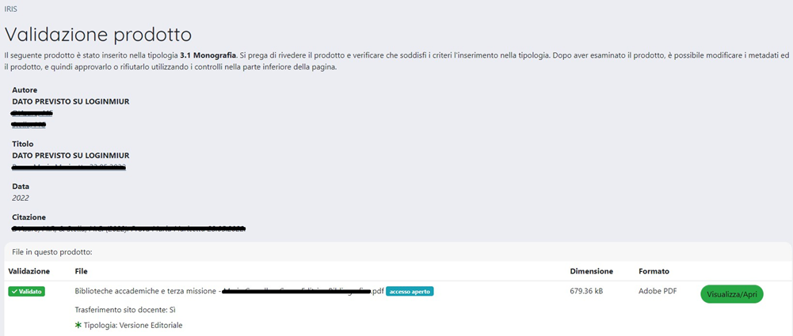
- the summary table relating to the file(s) with its/their characteristics (including pdf validation info)
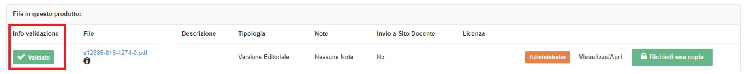
- a set of buttons (See section 6 Other buttons) from where you can perform some operations on the product card.
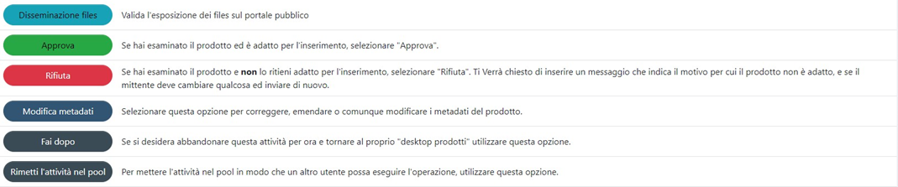
Once the necessary checks have been carried out, the Department Director or his Delegate proceeds by clicking on the green Approva (Approve) button.
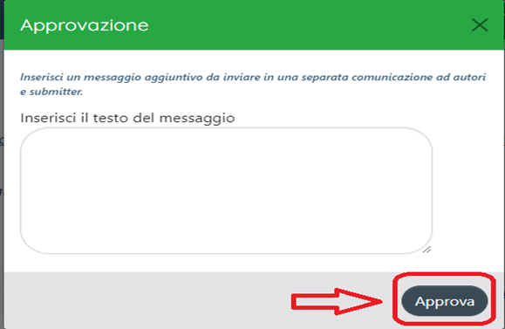
At this point the product will be assigned a persistent identifier handle (10447/XXXXX).
After approval, the product will be published on the public portal and sent to LoginMiur.
Normally the Director will handle products with pdf validated by the librarian (i.e. marked in the summary string of the file information by the green tick "Validato” (Validated) - as shown in the figure). In this case these are products whose access policy has been checked and selected
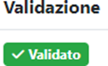.
Only in extreme cases, where the librarian has encountered controversial and not easily solved situations, the Director will find the entry Not Validated as Info validation:
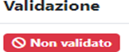.
In case of need, the Director may still proceed to Approval of the product, of which only the metadata will be displayed on the public portal.
On the other hand, the sending of metadata and files to LoginMiur is completely independent from the validation of the PDF.
If the Department Director or his/her Delegate does not intend to definitively accept the product, he/she may click on the "Rifiuta” (Reject) button, justifying his/her choice by filling in the appropriate box.

6. Other buttons
On the summary page from which one proceeds to approve and reject the validation of a product, there are also the following buttons
 (do it after): Allows you to temporarily suspend the activity. The product will remain a task of the user who made that choice can be found in the “My tasks” box.
NB: The product will not be visible to the other users enabled for departmental management.
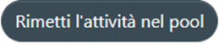 (return task to pool): Allows you send the activity back to the “Incarichi disponibili” (Items to be validated)” box so that another user can carry out the operation.

WORKFLOW GRAPHICS
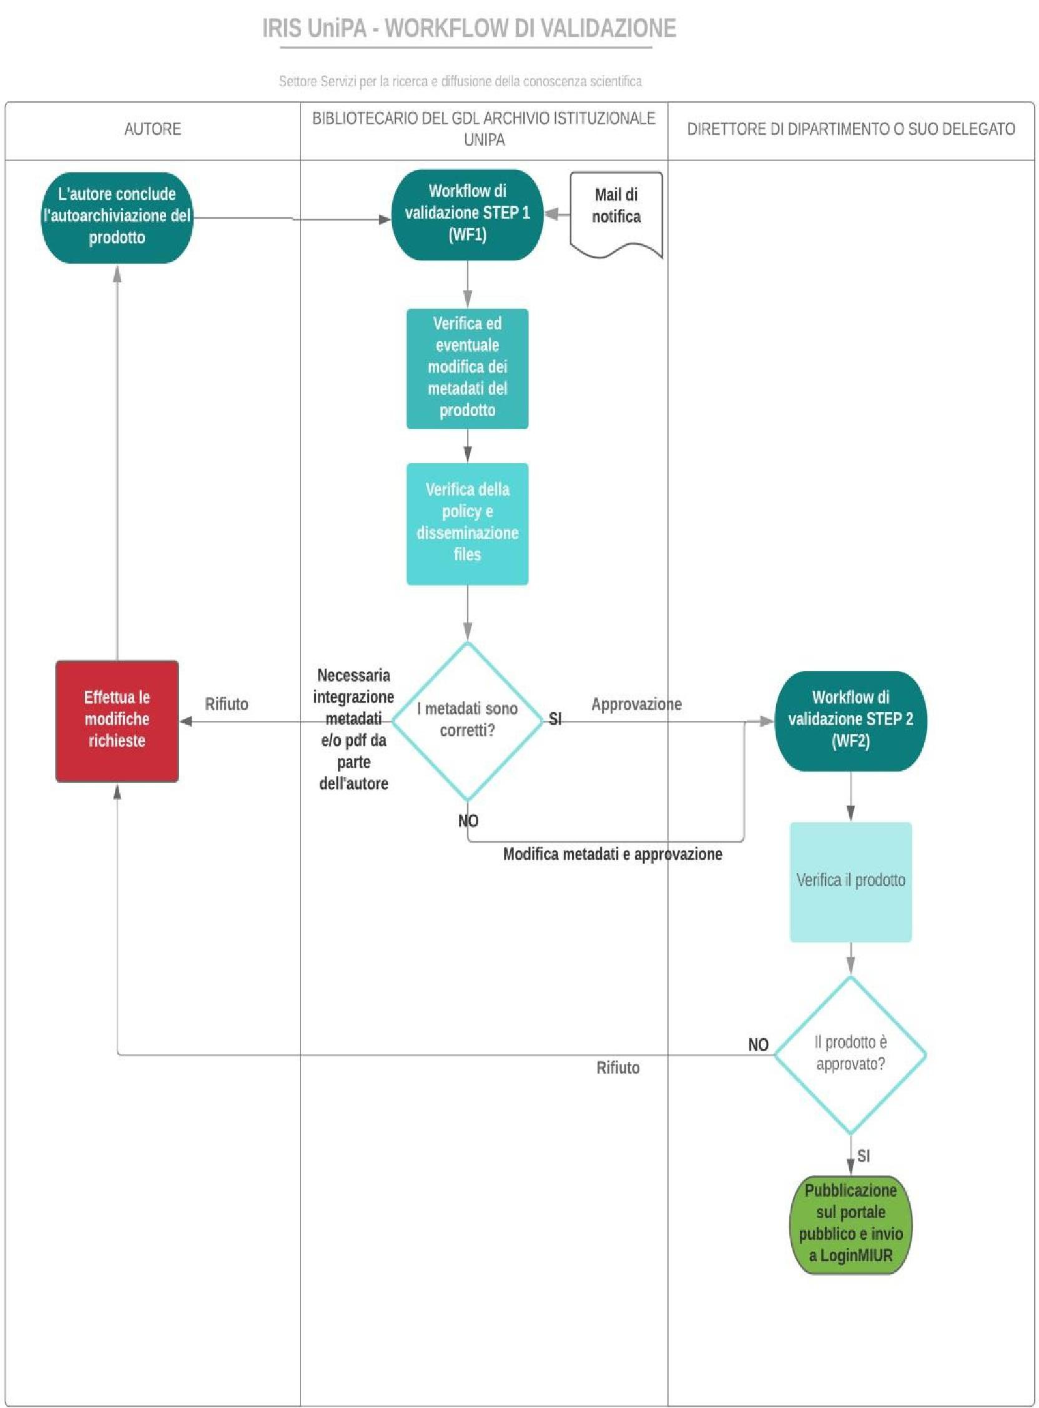
The author finishes self-archiving the product
Validation workflow STEP 1 (WF1)
Validation workflow STEP 2 (WF2)
Publication on the public portal and sending to LoginMuir
IRIS UniPA - VALIDATION WORKFLOW
Services sector for research and dissemination of scientific knowledge
AUTHOR
UNIPA GDL INSTITUTIONAL REPOSITORY LIBRARIAN
DIRECTOR OF DEPARTMENT OR HIS/HER REPRESENTATIVE
Notification email
Check and possible modification of the product metadata
Check on policy and file dissemination
Performs the required modifications
Refusal
Refusal
Approval
Are the metadata correct?
Necessary supplement of metadata and pdf by the author
Modification of metadata and approval
YES
YES
Verify the product
Is the product approved?

Workflow Step 1
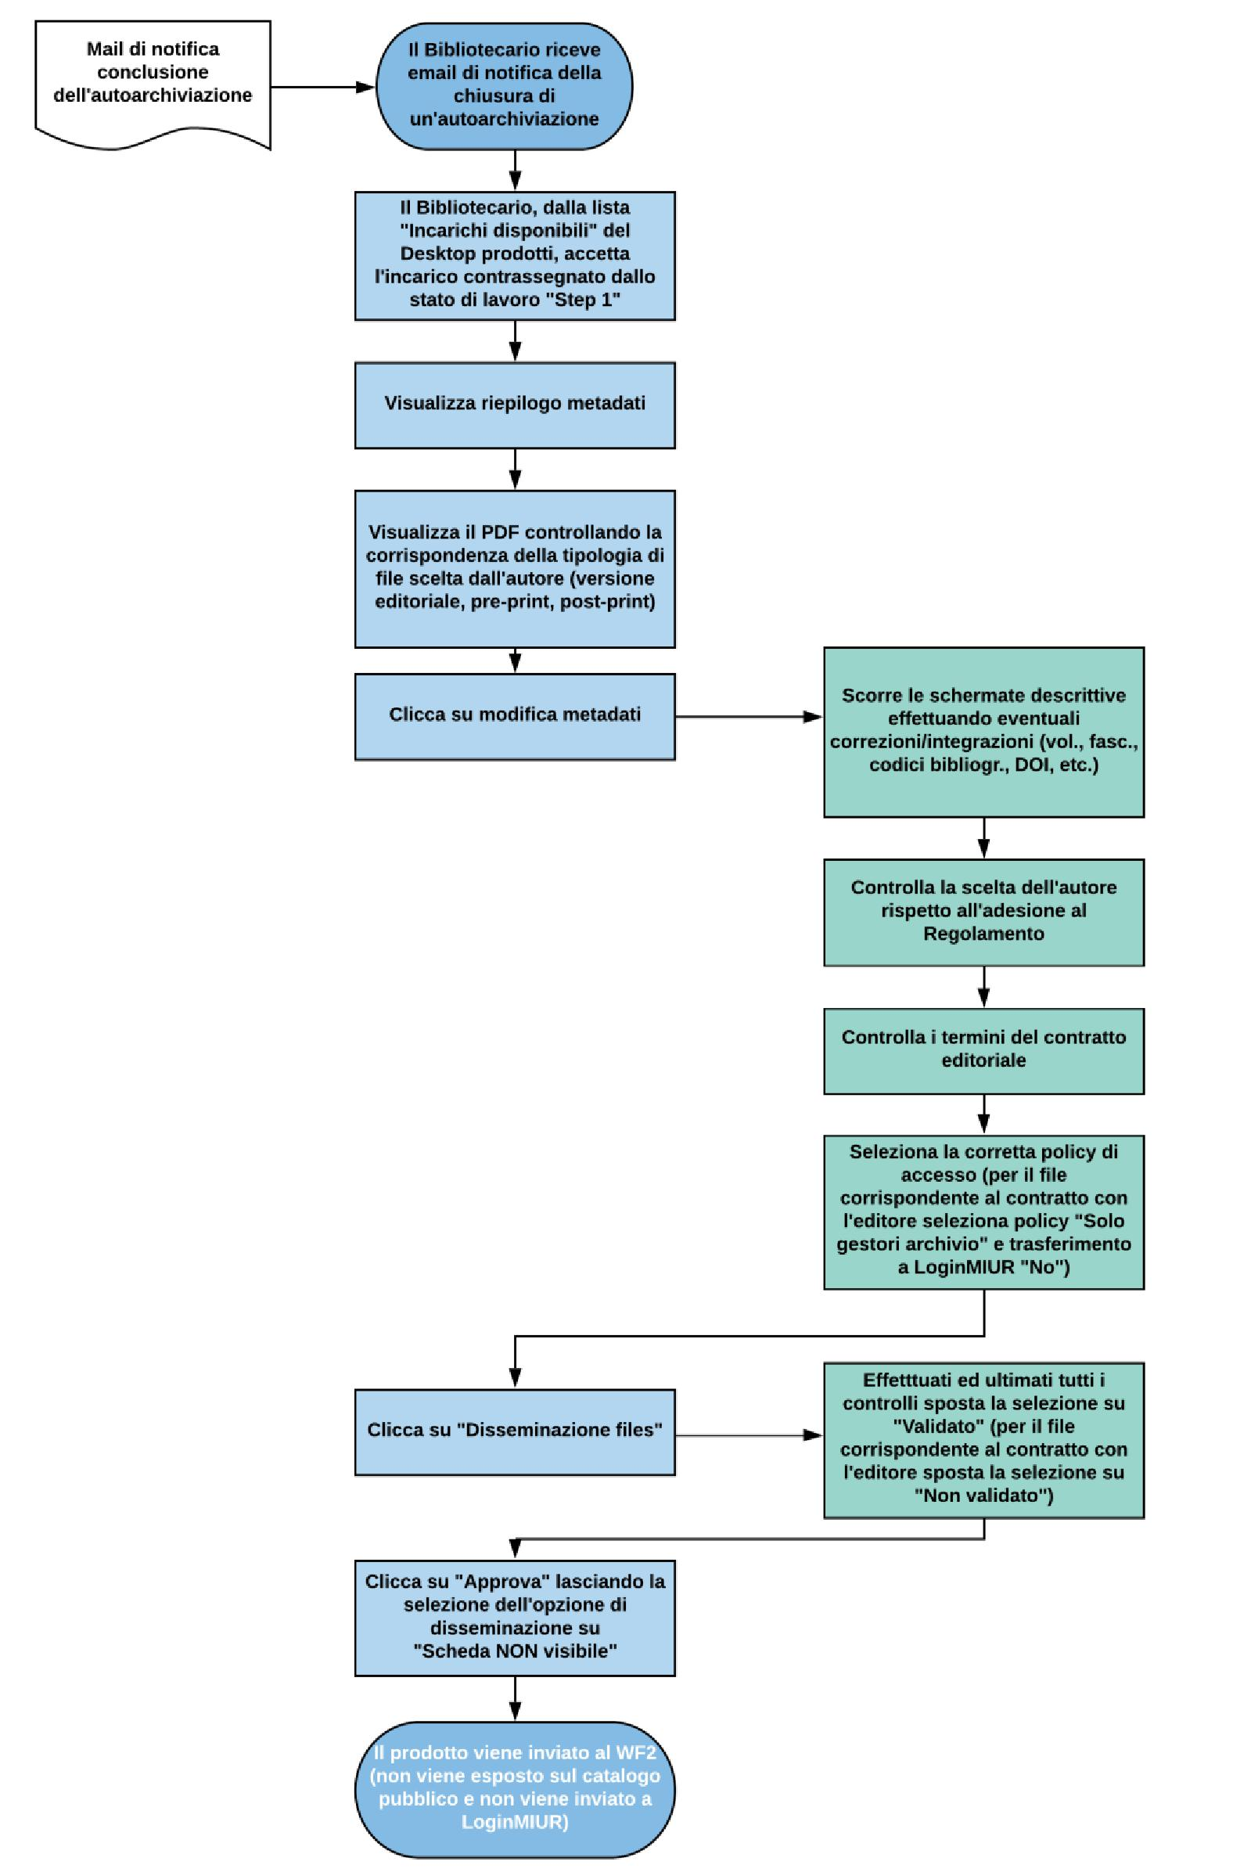
The librarian receives an email notifying the end of self-archiving
The product is sent to WF2 (it is not shown in the public catalogue and is not sent to LoginMIUR)
Email notifying the end of self-archiving
The librarian accepts the task marked by workflow status "Step 1" from the list of "Available tasks"
Displays metadata summary
Displays the PDF checking that it corresponds to the type chosen by the author (publisher's version, pre-print, post-print)
Clicks on edit metadata
Clicks on "Files dissemination”
Clicks on "Approva” (Approve)" leaving the dissemination option selection on "Card NOT visible"
Scrolls the descriptive screens making any corrections/additions (vol., issue, bibliographic codes, DOI, etc.)
Checks the author's choice regarding adherence to the Regulations
Checks the terms of the contract with the publisher
Selects the correct access policy (for the file corresponding to the contract with the publisher selects " Administrators” () and for transfer to LoginMIUR "No")
Once all the checks have been carried out and finalised, moves the selection onto "Validated" (for the file corresponding to the contract with the publisher moves the selection onto "Not validated"}

Validation workflow, Step 2
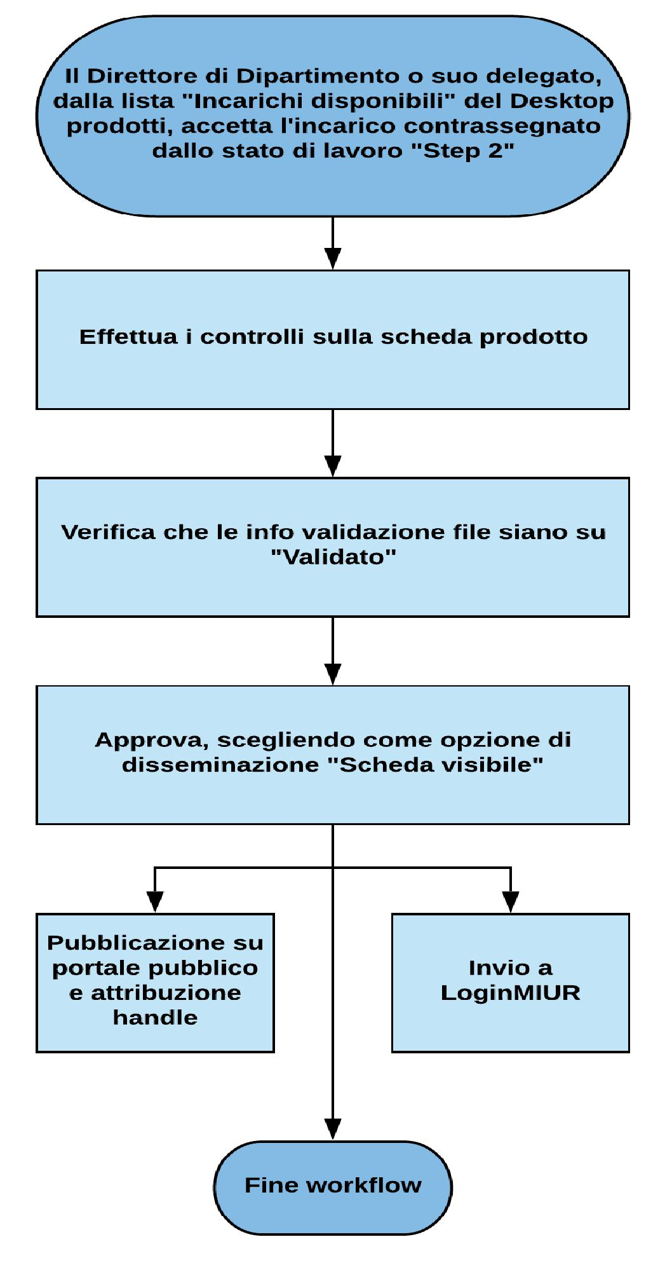
The Director of Department or his/her representative accepts the task marked by workflow status "Step 2" from the list of "Available tasks" in the products desktop
End of workflow
Performs the controls on the product card
Checks that the validation info files are on "Validated"
Approves choosing "Card visible" as dissemination option
Publication on public portal and allocation of handle
Sending to LoginMIUR

ANNEX 1 – FORM FOR GRANTING PROXY FOR RESEARCH PRODUCT VALIDATION WF2
To the Coordinators of the Working Group for the management of the Institutional Repository and open access
To the manager of the Research Records and Relations with CINECA OU
To the Librarian .....................................................
Re: Validation workflow for research products in Iris Unipa - Granting of WF2 Proxy
The undersigned Prof. , Director pro tempore of the Department ...............................................................................................................................................
grants the librarian proxy, assigned with Decree of the Rector 1661/2018 prot. no. 42128 of 08.06.2018 as amended for the above-mentioned Department, to carry out the activities linked to WF2 of the research product validation workflow in Iris Unipa.
Palermo,
Signature

ANNEX 2
Instructions for the embargo of research products
The embargo is a period of time after the publication of a scientific contribution during which full-text access to the file archived in the repository is restricted by University only for purposes of official research evaluation and/or for other administrative and managing purposes.
The embargo can be applied for in specific circumstances (e.g.: dissertation subject to agreements with publishers and/or external research financers; public/national security reasons; privacy or sensitive data; a patent in course of publication).
The embargo, if it is not mentioned in the research product itself, must be communicated by the author to the Working Group in order to check the correct policy for access in the Institutional Repository.
Except specific agreements in place with publishers and/or external research financers, the embargo period will range from six to twelve months (which may be extended until twenty-four months under exceptional reasons), then the contribution will be openly accessible in the repository.

