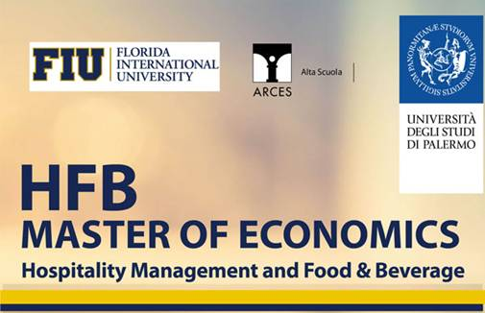

**30 Stage with reimbursement of expenses for the most deserving students and 11 scolarships covering the total cost of the course: registration are open for the Third Edition of "Master of Economics Hospitality Management - F & B" organized by the University of Palermo, Florida International University and Collegio Universitario ARCES.**

**Are you looking for a job in the tourism, hospitality and food and beverage?**

**It’s easy with the "Master of Economics Hospitality management - F & B" organized by the University of Palermo, Florida International University and the Collegio Universitario ARCES. The Master will be held in Palermo from April to December 2016.**

**30 are the internship grants offered by the leading companies in the hospitality industry in Italy and abroad and 11 scholarships that fully cover the fees of the master: 10 INPS scolarship (former Inpdap) for children of civil servants and 1 scolarship about the value of € 3,800.00 offered by Manageritalia.**

Among the companies that offer 30 internship grants for the best students there are: **Forte Village Resort**, **Cantine Planeta** (Menfi e Sicilia), **Donnafugata Golf Resort** (Marina di Ragusa), **NH Hotels** (Hotels in Europa), **Hands on Sicily di New York**, **Charme and Relax** (Catena Alberghiera), **GHS hotel** (Catena Alberghiera), **Eden Hotels and Resort**, **Palazzo Brunaccini** (boutique Hotel), **Abbazia Santa Anastasia**, **Le Cucine di Villa Reale**, **Villa Igiea**, **FUD Bottega Sicula**, **Hotel Porta Felice** (Palermo), **Hotel Baia del Capitano** (Cefalù), **Mari del Sud** (Vulcano-Isole Eolie), **Hotel Politeama** (Palermo), **Errequadro** (Palermo ed Hotels in Italia), **Agrirelais Baglio di Pianetto** (S. Cristina Gela), **Monaci delle Terre Nere**, **Villa Athena** (Agrigento), **PRC Repubbliche** (Palermo), **Locanda Gulfi** (Sicilia), **San Lorenzo Mercato**, **Costa degli Ulivi Hotels** (Sicilia), **Massimo Plaza Hotel** (Palermo), **Hotel Posta** (Palermo).

You can participate in pre-motivational interviews by filling out [**the on line form**](http://www.arces.it/public/portale/form/2016/hospitality_management_2016.asp).

Registration is now open and will close on 18th  of March 2016.

For information please visit the website [**www.masterhospitalitymanagement.it**](http://www.masterhospitalitymanagement.it/) or call the number +39 091346629.

The Master offers a particularly innovative formula: please see the Master [**Brochure**](http://www.arces.it/public/Alta_Scuola/Anno2016/Brochure_Master_hospitality_2016_2017_web.pdf)

In the section of the Arces web site dedicated to the master you can see the HFB Curriculum. The overall duration of the HFB Master is one academic year, with a total of 60 credits/1,500 hours divided into:

**700 hours of internship**

following a training scheme designed in collaboration with the host enterprise.

**400 hours of independent study**

for project works and study.

**360 hours of lessons taught in English**

(April-May / November-December 2016 and January 2017) taught by internationally renowned professors and industry-professionals, covering management models, tourism marketing, and the fundamentals HFB techniques.

**40 hours of special-topic seminars in English**

With HFB experts.

The faculty of the master is composed by professionals of the tourism industry of international reputation.

Download  the [**HFB Master Hospitality Management Call**](http://www.unipa.it/amministrazione/area1/ssp03/uob03bis/.content/documenti/Hospitality-Management-and-Food--Beverage-M187.pdf)

Download  [**Application Form for admission to the selection**](http://www.unipa.it/amministrazione/area1/ssp03/uob03bis/.content/Modulistica/Domanda-di-Partecipazione-Master.pdf)

**Visit** [www.arces.it/hfb](http://www.arces.it/hfb) **and** [**www.masterhospitalitymanagement.it**](http://www.masterhospitalitymanagement.it/)

**Application Deadline: 18th of March 2016**

**Visit:**

[http://www.arces.it/public/immagini/Social_Network/youtube.png](https://www.youtube.com/user/arcesaltascuola)

[**The Youtube Channel of the Master in Hospitality Management and Food & Beverage**](https://www.youtube.com/user/arcesaltascuola)

[http://www.arces.it/public/immagini/Social_Network/images.jpeg](https://www.facebook.com/pages/Master-of-Economics-Hospitality-Management-FB/742289572533795)

[**The Facebook Fan Page of the Master Hospitality Management and Food & Beverage**](https://www.facebook.com/pages/Master-of-Economics-Hospitality-Management-FB/742289572533795)

**INFO**

ARCES Collegio Universitario

Vicolo Niscemi, 5 – 90133 Palermo Tel. +39 091 346629

Clelia Giordano - [c.giordano@arces.it](mailto:c.giordano@arces.it)

Monica Segretario – [m.segretario@arces.it](mailto:m.segretario@arces.it)

Coordinatore Master Prof. Ruggieri: [master.hfb@unipa.it](mailto:master.hfb@unipa.it)